CHUA, Kyle Rendell G.

2 ECE-E

**Problem 1**

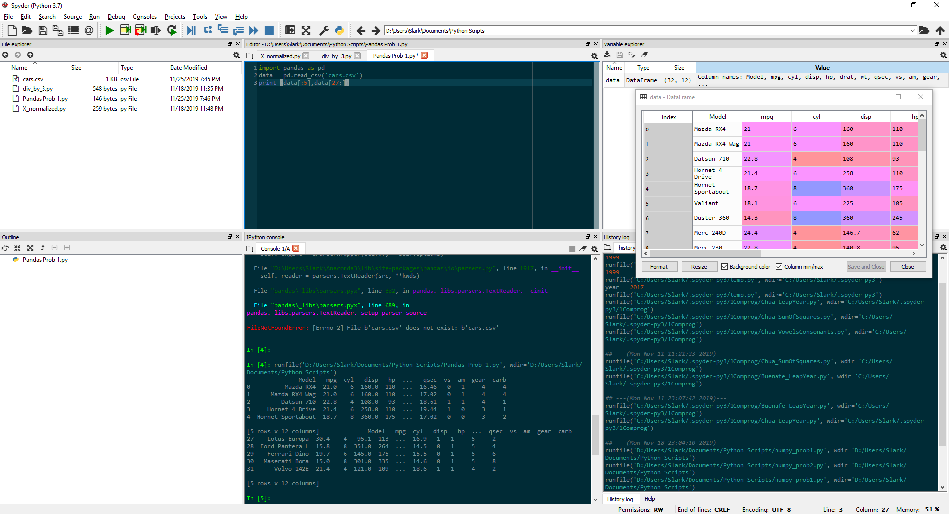

**Problem 2**

1. Display the first five rows with odd-numbered columns of cars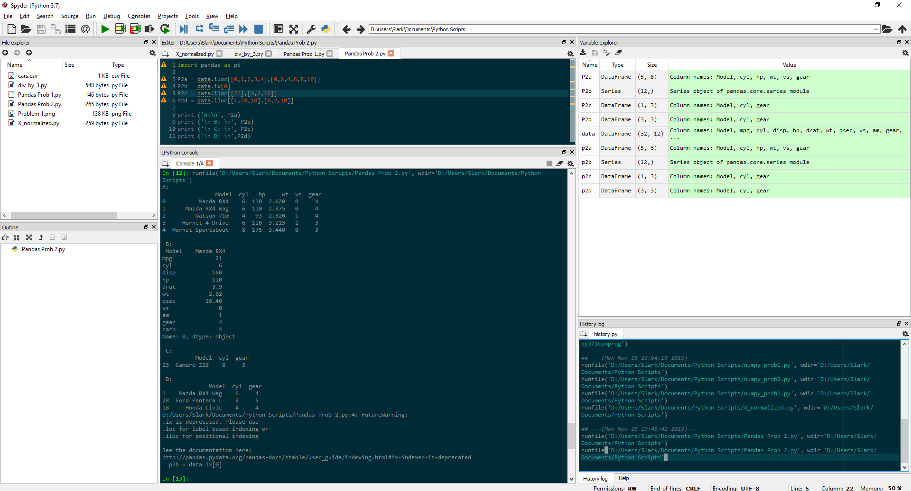
2. Display the row that contains the model of Mazda RX4
3. How many cylinders and what gear type does the car model ‘Camaro Z28’ have? 
4. Determine how many cylinders and what gear type do the car models ‘Mazda RX4 Wag’, ‘Ford Pantera I’, and ‘Honda Civic’ have. 